**Creation and Update the task processes in ScrumDo**

* Initially create an account in ScrumDo if you are a new user. Please use the following link to create an account: [*https://www.scrumdo.com/account/signup/*](https://www.scrumdo.com/account/signup/)

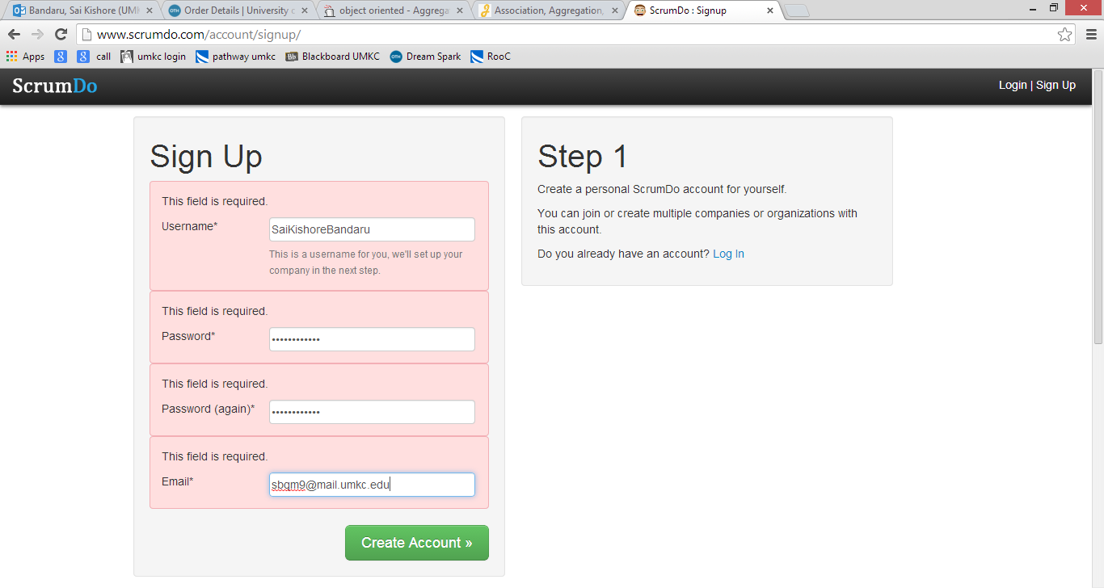

Figure Sign Up Document

* After creating the credentials, please enter the organization and select a Free Trial version.

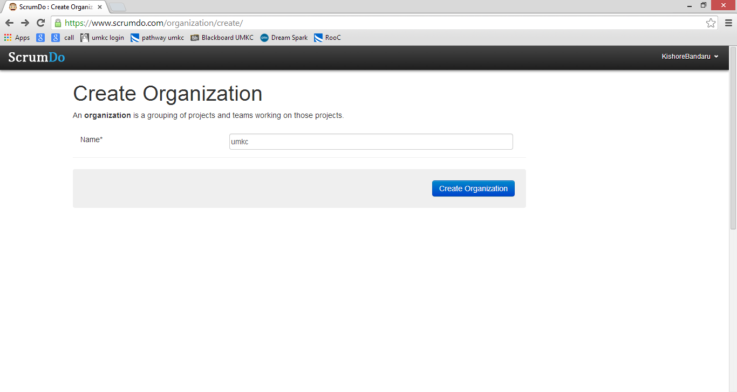

Figure Enter Organization Name

* Create a new project by clicking on “New Project” and name it.

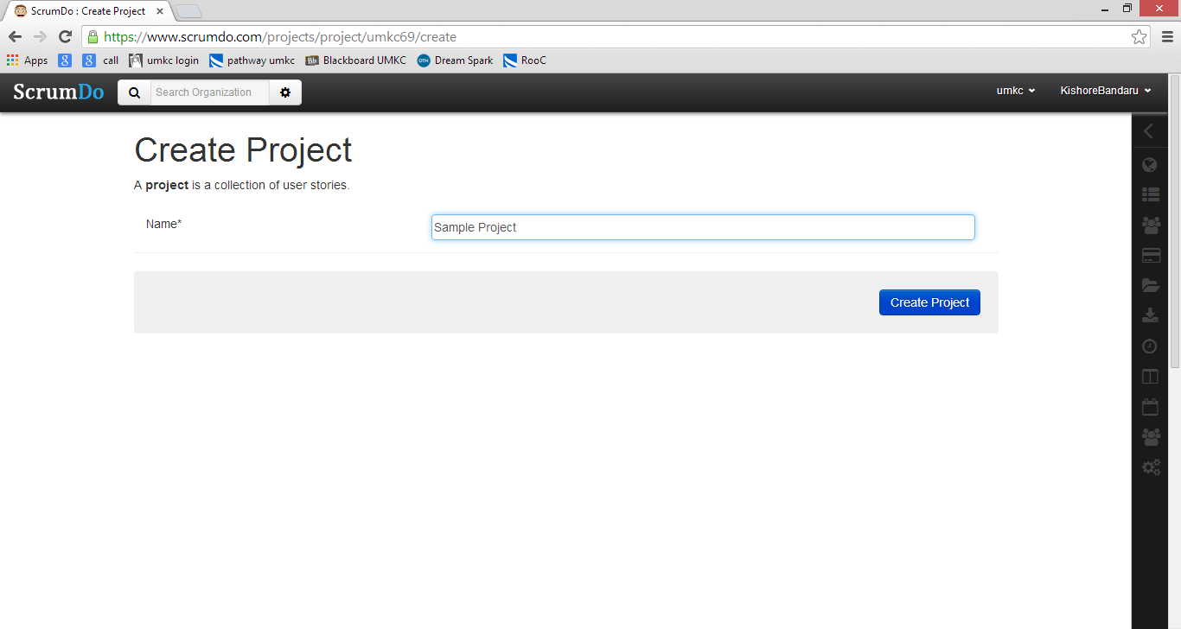

Figure Project Creation

* Now for the creation of a task in a iteration, initially we need to create an iterator.

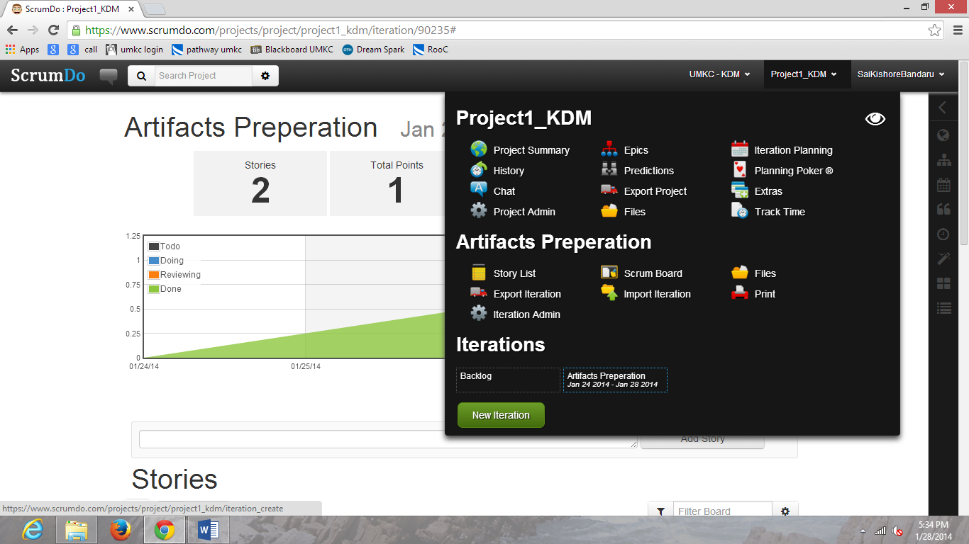

Figure Iteration Creation

* Enter the name of the iteration and the respective deadlines.

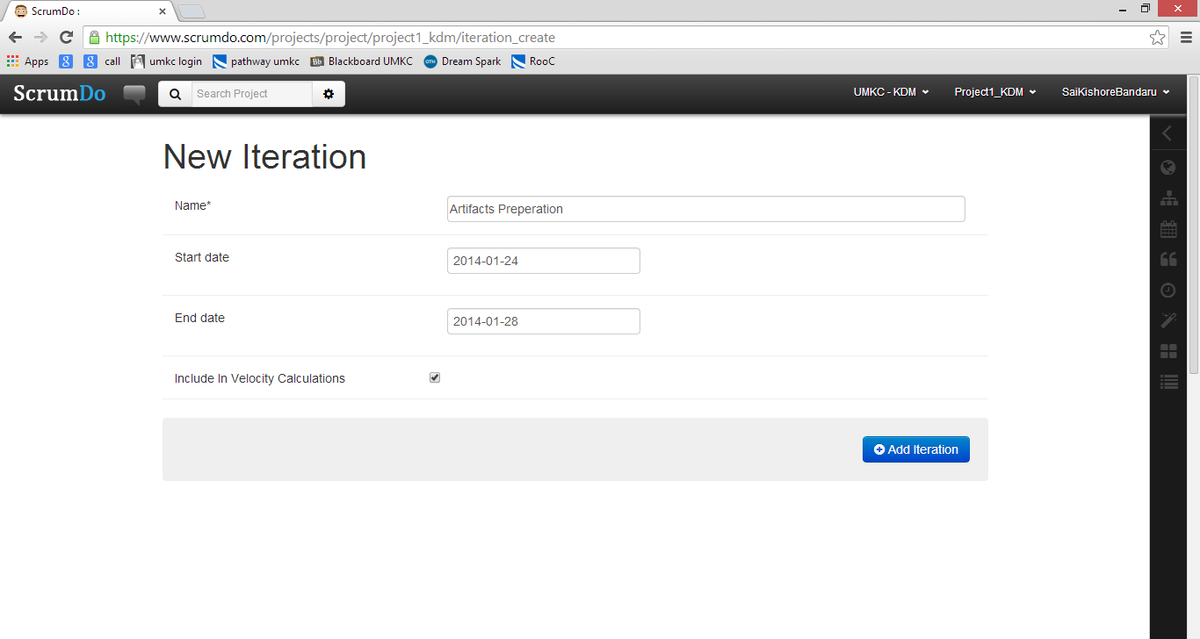

Figure Iteration Details

* Now select the created iteration from the project drop down and create a story. When you open the iteration there will be an option to Add Story. Enter the story details in the respective columns and add.

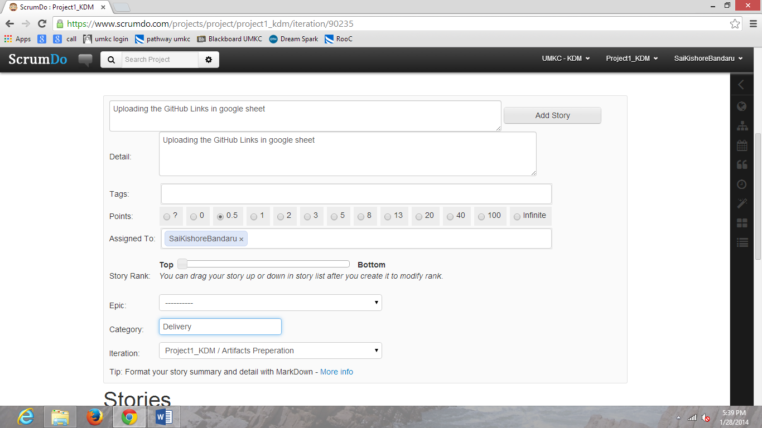

Figure Adding a story

* After creating the story based on the work that is being done on a day move the status of the story from todo->doing->reviewing->completed. This is done by clicking the “ScrumBoard” which gives the entire list of stories, where we can edit each of them.

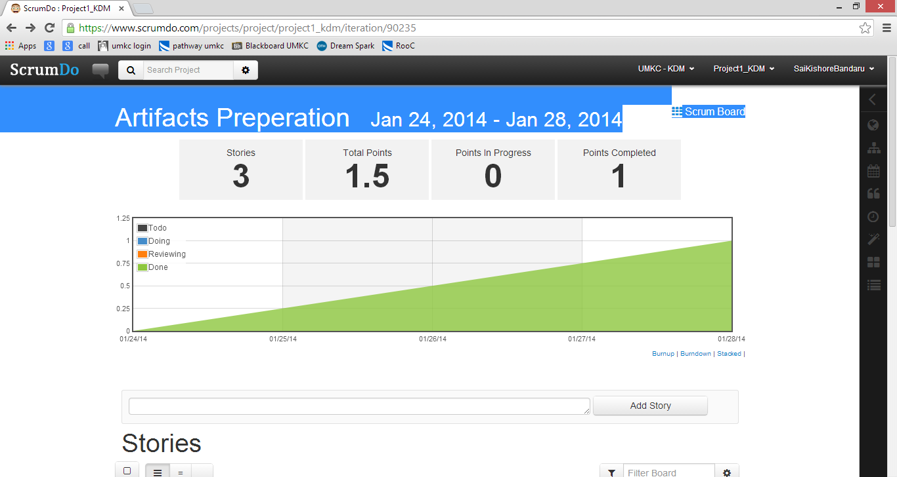

Figure Scrum Board for list of stories

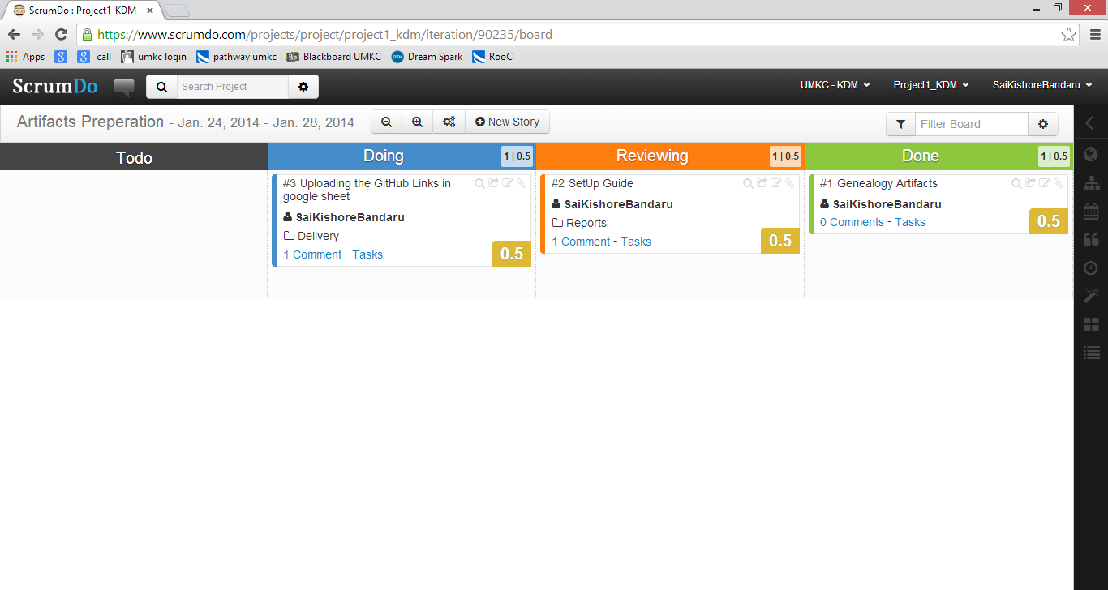

Figure Status of each story

* We can also enter comments for each story during each phase.
* Once all stories are completed we can see the graph of cumulative stories and their status.

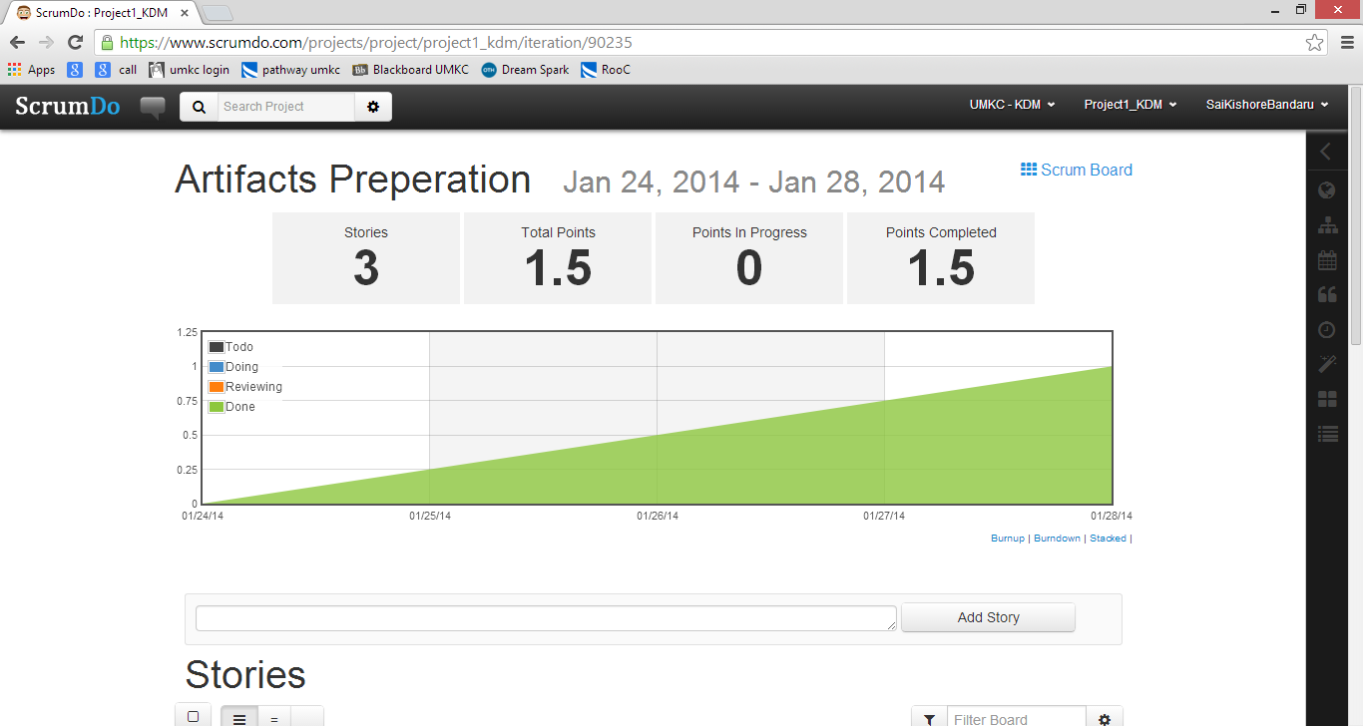

Figure Graphical representation of project status